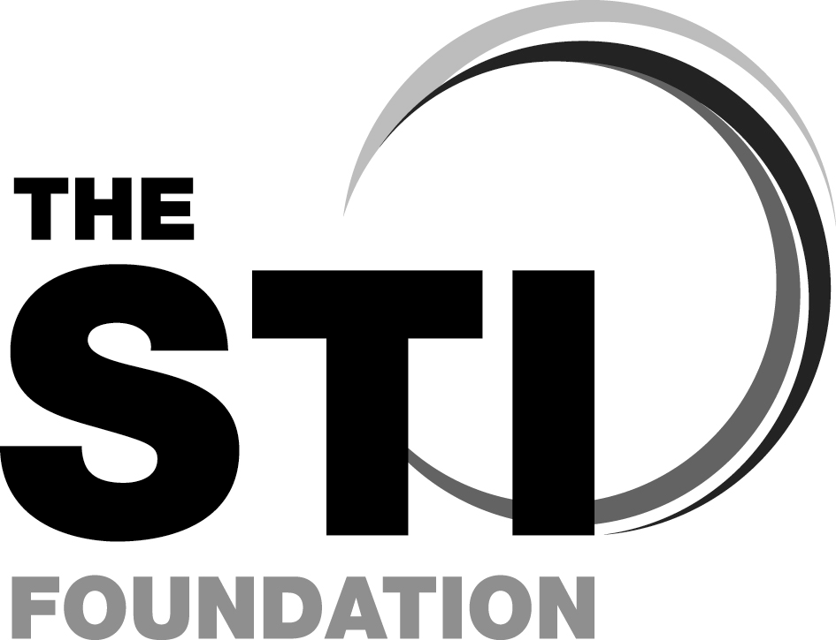

Sexually Transmitted Infections Foundation Course

STIF CORE

STIF PLUS

Updated and Revised Courses from the British Association for Sexual Health and HIV (BASHH)

STIF CORE:

Friday 30th September 2011

STIF PLUS:

Saturday 1st October 2011

At William Stokes Post Graduate Centre, St. James’s Hospital, Dublin 8, Ireland

COURSE DIRECTOR: Dr. Grainne Courtney, Department of Genitourinary Medicine and Infectious Diseases, GUIDE clinic, St. James’s Hospital, Dublin 8, Ireland

COURSE ORGANISERs:
Dr. Fiona Lyons, Consultant in Genito-Urinary Medicine
and Ms. Sandra Delamere, Advanced Nurse Practitioner (Sexual Health)
Department of Genitourinary Medicine and Infectious Diseases, GUIDE clinic, St. James’s Hospital, Dublin 8, Ireland

(on behalf of BASHH)

The aim of the course is to equip participants with the basic knowledge, skills and attitudes for the effective management of sexually transmitted infections (STIs) outside the GUM setting.
Early registration is preferable.

It is highly recommended that delegates study the appropriate modules in e-Learning for Health before attending.

This will entail around 5 hours of study. Further information about the modules will be provided by the course organisers approximately four weeks before the course commences.

For further information please visit http://www.bashh.org/stif

This is a multi-disciplinary course and applications are invited from:
Doctors and nurses working in general practice, family planning and reproductive health, GUM, health advisers, secondary care clinicians who may encounter patients with STIs (e.g. O&G, A&E, rheumatology and ophthalmology), pharmacists, school nurses.

Course fee (includes Coffee, Lunch & Tea)
STIF Core €210. STIF Plus €210. BOTH DAYS € 400

To reserve a place, please return the tear-off slip below, with a cheque made payable to GUM Department Current Account

ALL APPLICATIONS SHOULD BE
RETURNED BY Friday 28th of August 2011

Details of the e-learning modules and a Course Pack will be sent to you nearer the time with your receipt.

ICGP and An Bord Altranais approved

Sexually Transmitted Infections Foundation Course
Friday 30th September and Saturday 1st October 2011

William Stokes Post Graduate Centre, St. James’s Hospital, Dublin 8, Ireland

Name______________________________________
Present Post __________________________________________

Place of Employment _________________________

Mailing Address for your course pack:
______________________________________________
_______________________________________________

____________________________Post Code:___________
Daytime Telephone contact: ________________________________
E-mail ________________________________________________
Please indicate the days which you wish to attend:
◻ DAY ONE (STIF CORE) €210
◻ DAY TWO (STIF PLUS) €210
◻ BOTH DAYS €400
Any Special Needs? (Please specify) _______________________

Please return completed application to
Ms. Carol Murray, Clerical Supervisor, GUIDE Clinic, Hospital 5
St James’s Hospital, Dublin 8
Tel: 01 4103524 E-mail: guidesuper@stjames.ie OR sdelamere@stjames.ie

BASHH - STI Foundation Course (Outline programme)

Aim of the course
To equip participants with the basic knowledge, skills and attitudes for the effective management of STIs.

By the end of the course you should be able to:

Knowledge
- describe the principles of STI service provision
- recognise the issues relating to confidentiality, partner notification and treatment
- demonstrate basic knowledge of the epidemiology and the factors involved in the transmission of STIs and how to prevent transmission
- demonstrate basic knowledge of STIs, their presentation, diagnosis and management
- indicate where and when to refer patients

Skills
- demonstrate competency, and feel comfortable, in taking a sexual history
- demonstrate the skills necessary to inform patients about reducing their risk of sexual infections and risk of unplanned pregnancy
- optimise care pathways for patients through improved links with local services (GUM, Sexual Health, Contraceptive services, Psychosexual services, Microbiology, TOP services and Primary Care)

Attitudes
- demonstrate an appreciation of the lifestyle and circumstances of others and how this may reflect in their presentation and impact on their management.
- recognise the range of human sexuality, lifestyles and culture and the impact this has on transmission/prevention counselling
- demonstrate an understanding of how one’s personal beliefs could affect the consultation

Programme timings may change

Day 1 (STIF CORE ):

09:00 Registration and coffee
09:30 Welcome, introduction –
09:40 Session – Overview of STI’s including epidemiology and principles of service provision in Ireland
10:20 Session – taking a sexual history, risk assessment and recognition of symptoms
11:00 Coffee
11:15 Session – Examination, swabs and tests
12:00 Session - Partner Notification / Prevention, Control and Health Promotion
  - Lunch
13:30 Small Group Workshops: divide into 4 groups for day 1

 | Group A | Group B | Group C | Group D
13:30 | 1 | 2 | 3 | 4
14:00 | 2 | 3 | 4 | 1
14:30 | Tea | Tea | Tea | Tea
14:45 | 3 | 4 | 1 | 2
15:15 | 4 | 1 | 2 | 3

15:45 Questions and answers
16:15 Close

Small Group Workshops:
1. Genital sores
2. HIV testing in practice
3. Vaginal Discharge and Pelvic Pain
4. Young People and Sexual Health

Day 2 (STIF PLUS):

09:00 Coffee and registration
09:30 Session – HIV in primary care: recognition and management
10.30 Coffee
10:45 Small Group Workshops: divide into 2 groups for day 2
 | Group A | Group B
10:45 | 5 | 6
11:30 | 6 | 5

  - Lunch

13.00 Session: – Sexual Assault
13.45 Small Group Workshops:
 | Group A | Group B
13.45 | 7 | 8
14.30 | 8 | 7

15:15 Tea
15:30 Session – Syphilis
16:00 Session - Motivational Interviewing in Sexual Health
16:30 Questions and Answers
16.45 Close

Small Group Workshops:
5. Male dysuria, prostatitis, testicular pain
6. Genital Dermatology
7. Viral Hepatitis
8. Sexual Health for Gay Men and Lesbians

